IGC–Addis Ababa University Workshop
Functioning Labour Markets to Foster Structural Transformation in Ethiopia
5 February 2026 | Addis Ababa University (AAU), Ras Mekonnen Hall
Organised by: International Growth Centre (IGC), Ethiopia and Addis Ababa University of the Centre for Sustainable Development

Introduction
On 5 February 2026, the International Growth Centre (IGC) Ethiopia and Addis Ababa University (AAU) of the Centre for Sustainable Development (CSD) jointly organised a policy-oriented workshop titled “Functioning Labour Markets to Foster Structural Transformation in Ethiopia.” The workshop brought together policymakers, development partners, academics, and practitioners to discuss how labour-market frictions shape job creation and the pace of structural transformation in Ethiopia, and what practical policy and implementation choices can strengthen employment outcomes.
Ethiopia’s structural transformation remains a central development priority, particularly at a time when the demand for productive jobs continues to grow rapidly. While the country has seen important progress in expanding education and supporting economic activity, labour-market challenges persist—such as weak information flows between jobseekers and firms, skills signalling and certification constraints, segmentation between formal and informal work, and very high congestion in job application processes. These frictions affect both the private sector’s capacity to create and sustain employment, and the effectiveness of public employment services and labour-market programmes. Against this background, the workshop aimed to strengthen evidence-informed dialogue on how labour markets can better support inclusive growth and structural change.

Opening and participants
The workshop opened with welcome remarks by Dr. Hailu Elias, Director of AAU’s Centre of Sustainable Development, and Dr. Tewodros Mekonnen, Country Manager of IGC Ethiopia, who highlighted the value of sustained collaboration between universities, policy institutions, and development partners to ensure that research evidence directly informs policy design and implementation.
This was followed by an opening speech from Ato Ahmed Said, a senior official at the Ministry of Labour and Skills (MoLS), who reaffirmed the Government’s continued focus on improving employment outcomes and underscored the value of practical, policy-relevant evidence—particularly evidence that can strengthen labour market interventions under real-world constraints such as limited labour demand and intense competition for vacancies. He also noted that, alongside efforts to expand wage employment, government policy is increasingly prioritising self-employment as a key pathway for job and wealth creation. In this context, he encouraged the workshop to consider how certification and improved matching mechanisms may influence transitions into self-employment, and whether job-matching interventions should be complemented with mindset, entrepreneurship, or business support to better align with national policy priorities.
The workshop was attended by a wide range of participants, including senior and technical officials from MoLS, representatives of the Ethiopian Investment Commission, AAU leadership and faculty (including Prof. Alemu Mekonnen, Director of the Institute of Social & Economic Research (ISEC), the FCDO and World Bank staff in Addis Ababa, as well as researchers and practitioners working on jobs, industrialisation, and labour-market policy. The broad participation ensured that the workshop discussions connected research findings to the realities of policymaking and implementation.

Research presentations
The workshop featured five research presentations—three papers in the morning and two in the afternoon—covering both micro-level evidence (on matching interventions and programme delivery) and macro-level evidence (on industrial employment and the broader trajectory of structural transformation). The presentations were followed by a structured discussion, allowing participants to raise questions and reflect on implications for policy impact.

Morning session
1) Matching on Additionality (Prof. Stefano Caria)
The first presentation focused on job matching and the challenge of measuring whether programmes create net new jobs (“additionality”) rather than simply reallocating limited opportunities among jobseekers. The presentation discussed how matching interventions may be designed to prioritise placements where the vacancy is less likely to be filled in the absence of support, and how certification and related tools can improve information and trust in the labour market. This presentation resonated strongly with policymakers who are concerned not only with reported placements but also with whether interventions generate better employment gains at scale.
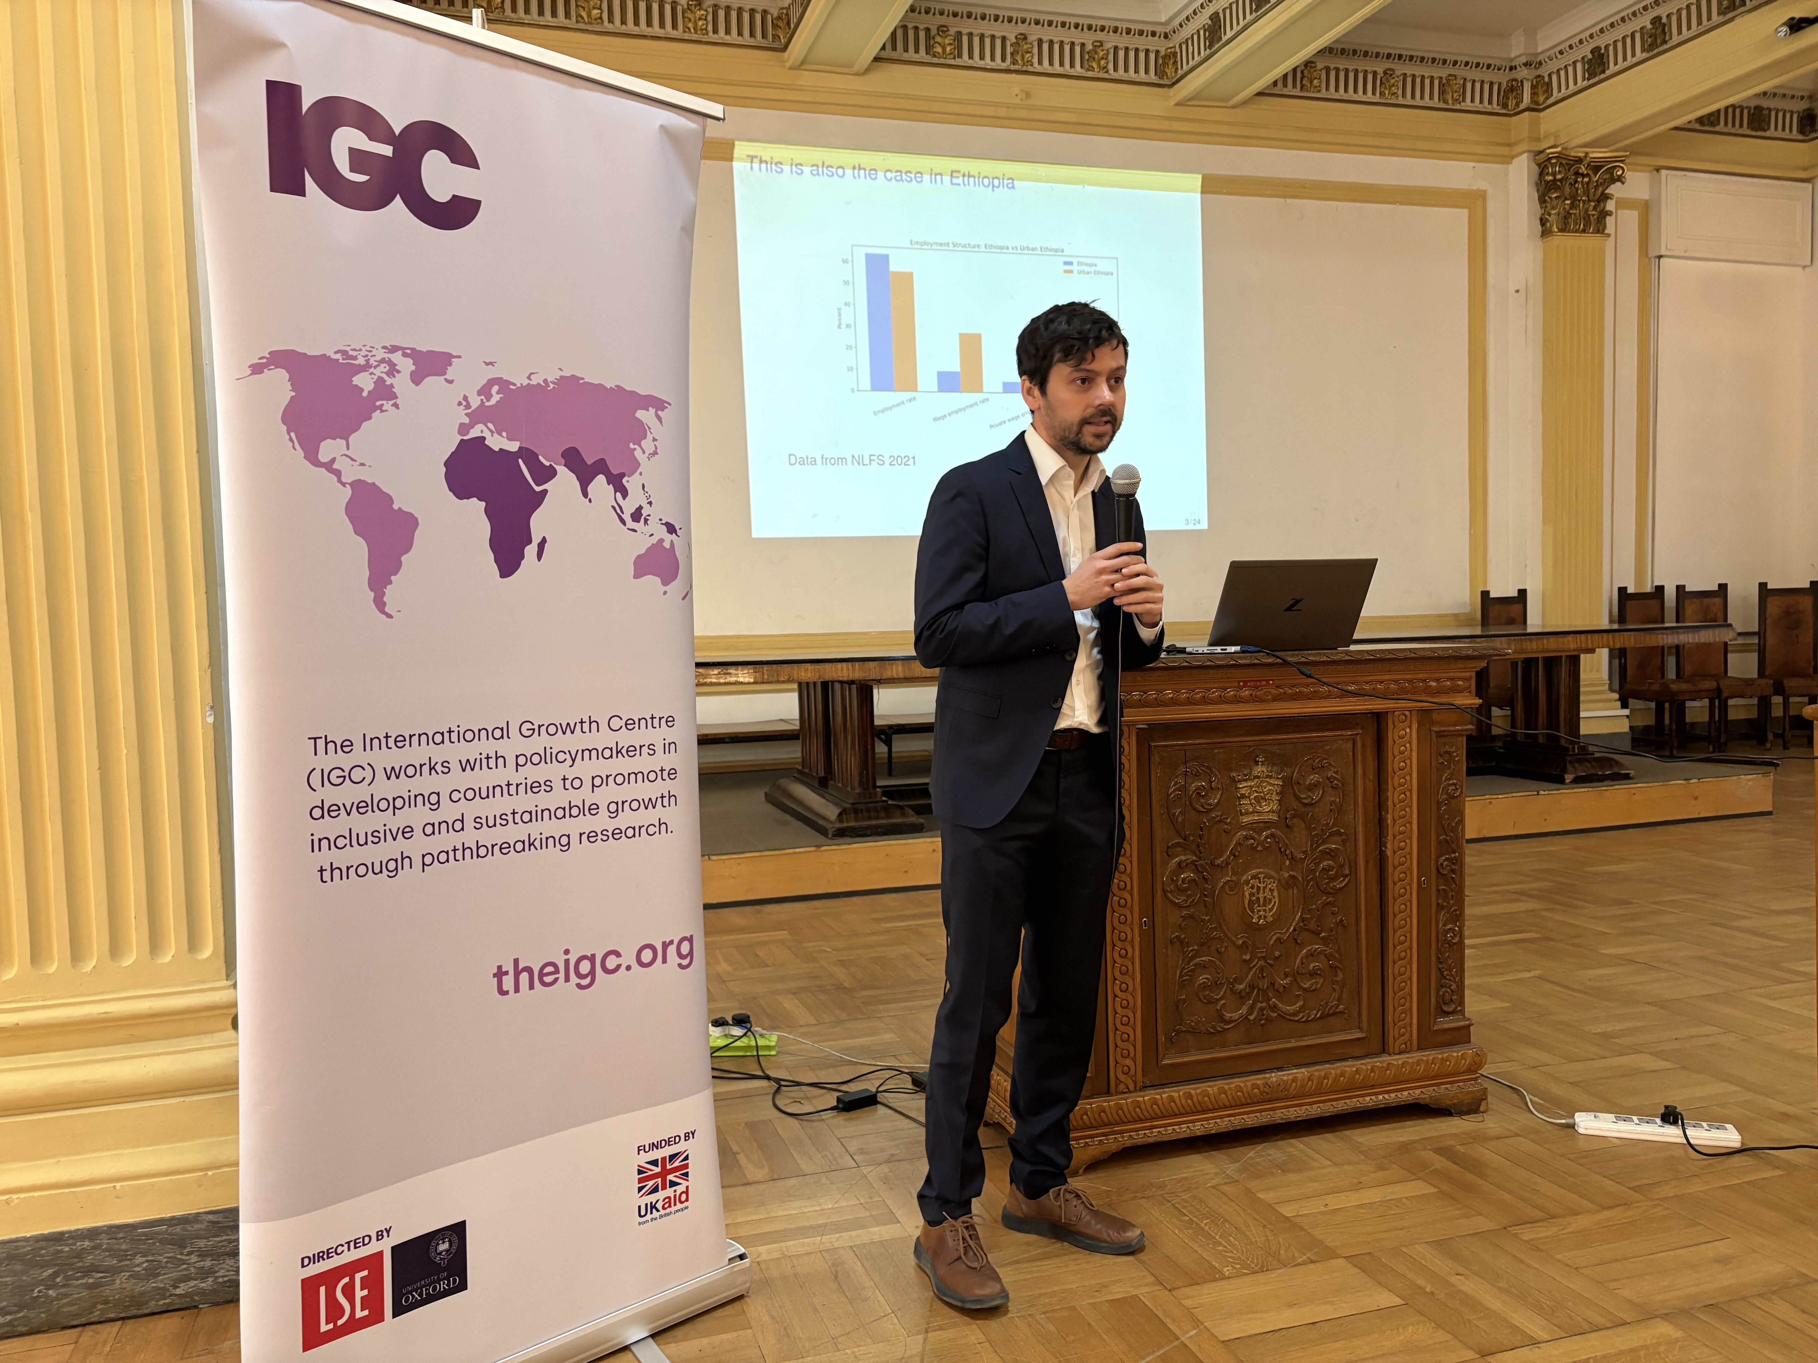
Figure 1: Prof. Stefano Caria presenting on “Matching on Additionality”
2) The Local (Informal) Multiplier of Industrial Jobs (Prof. Marco Sanfilippo)
The second paper examined how industrial jobs may generate spillovers into surrounding local economies—especially through effects on smaller firms and informal businesses. This topic is relevant to Ethiopia’s industrialisation agenda, where there is strong policy interest in how manufacturing investments translate into broader employment and local economic activity beyond direct factory jobs.
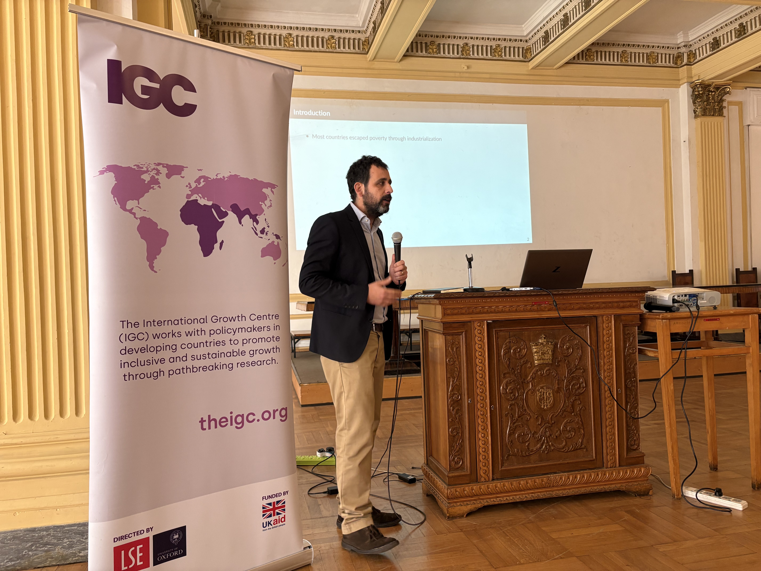
Figure 2: Prof. Marco Sanfilippo presenting on “Local (Informal) Multiplier of Industrial Jobs”
3) Labour Demand Dynamics across Production and Non-Production Tasks (Dr. Eyayu Tesfaye)
The third presentation explored firm-level labour demand behaviour, with a focus on differences between production and non-production labour, the existence of labour adjustment costs, and how firms respond to changes in wages and other costs. The presentation highlighted the importance of understanding employment volatility and adjustment processes—particularly when designing incentives, wage-related reforms, and policies that aim to support firm expansion and sustained job creation.
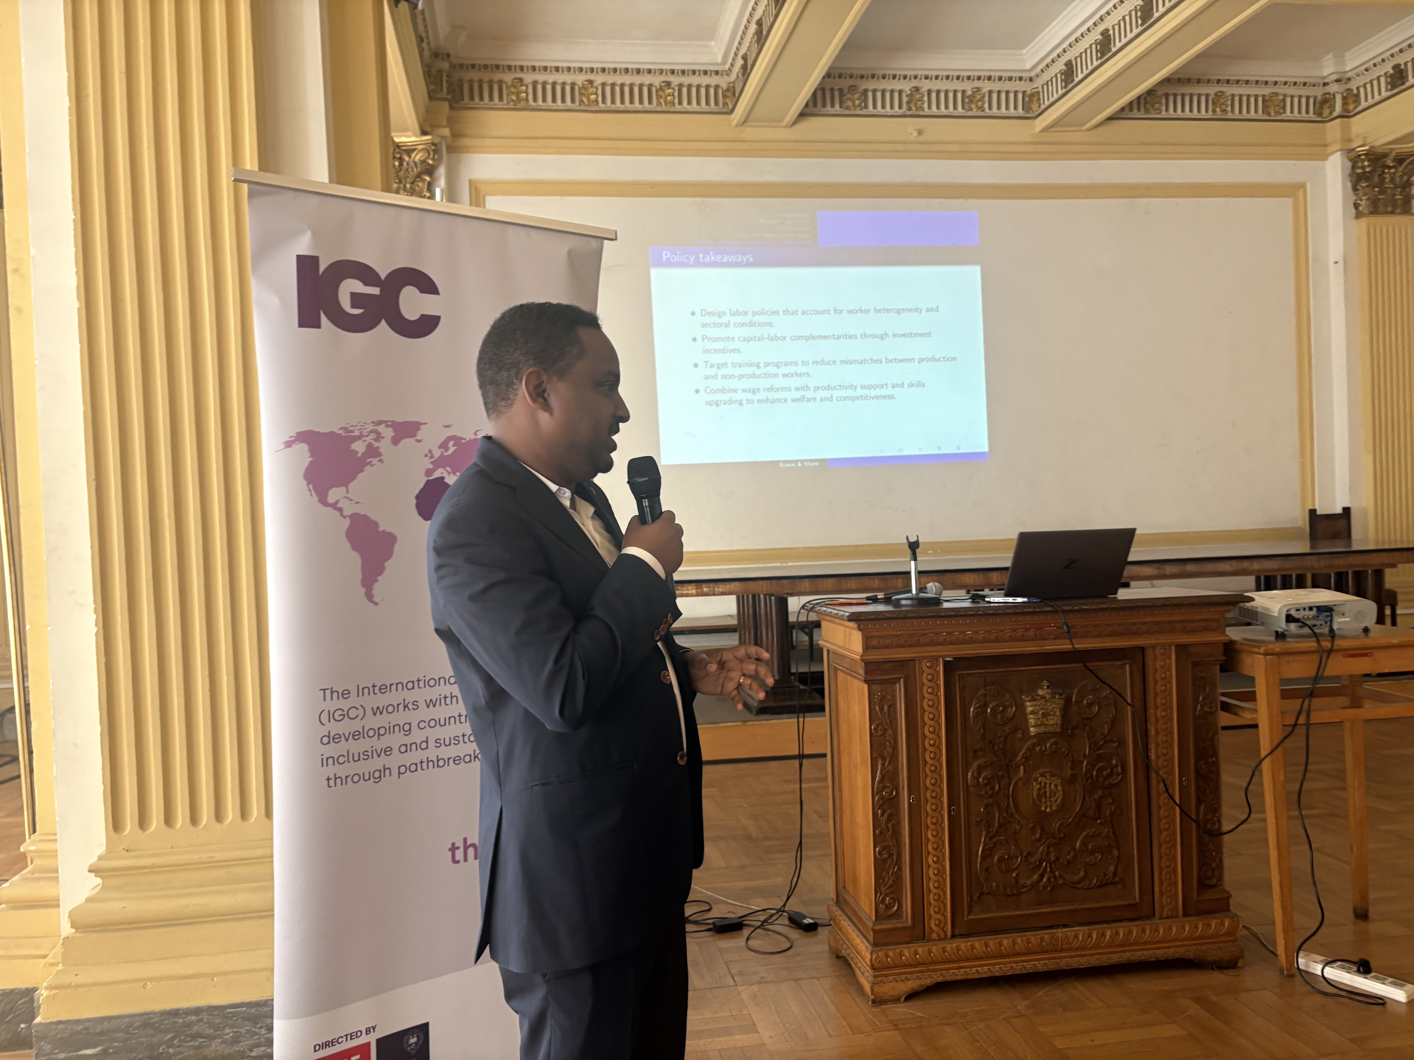
Figure 1: Dr. Eyayu Tesfaye presenting on “Labour Demand Dynamics”

Afternoon session
4) Bureaucrat–Firm Relationships and the Success of Labour Market Policy (Dr. Philipp Barteska)
The fourth paper focused on the implementation side of labour market policy. It examined how relationships between public officials and firms can shape programme effectiveness, and how stronger measurement systems—tracking not only vacancies, but also referrals, placements, and outcomes—can strengthen delivery. This presentation led to a rich discussion on how employment services can move from measuring activity (e.g., vacancies collected) toward measuring results (placements and retention), and how to improve administrative systems in practice.
5) Structural Transformation in Ethiopia: Services or Manufacturing? (Dr. Mulu Gebreyesus)
The final presentation provided a macro perspective on Ethiopia’s structural transformation pathway. It highlighted key trends in how labour shifts across sectors and discussed the employment implications of different growth trajectories, including the role of services and manufacturing. This framing helped link the micro evidence on matching and labour market implementation to the broader question of which sectors and policies are most likely to generate employment-rich growth.

Discussion: key issues raised by participants
The workshop generated active discussion, and participants raised a set of practical policy issues clustered around four themes. Importantly, presenters provided clarifications and responses to the issues raised, while MoLS participants also reflected on several points and linked them to current policy priorities.
1) Matching, certification, and additionality
Participants discussed how the proposed matching interventions differ from traditional employment programmes and how impacts should be interpreted in contexts where displacement effects are plausible. A core issue was whether measured employment gains reflect net additional jobs, rather than simply shifting outcomes across jobseekers. Participants also noted that certification and matching systems are increasingly being introduced in Ethiopian universities, raising questions about baseline conditions and how the new interventions interact with these emerging systems. Given the strong segmentation of Ethiopia’s labour market, participants emphasised that impacts may differ substantially across segments, and that external validity will depend on where constraints are most binding. Several participants further highlighted extreme labour-market congestion—where a single vacancy can attract very large applicant pools—and discussed implications for programme design, selection processes, and the credibility of randomisation under such conditions.

2) Self-employment, migration, and labour market policy priorities
Participants highlighted the policy relevance of self-employment and entrepreneurship, reflecting the Government’s increasing priority on self-employment pathways. Discussion considered whether certification and matching tools influence transitions into self-employment, and whether matching interventions should be combined with complementary support such as mindset or entrepreneurship programming. Participants also reflected on the interaction between labour market interventions and broader dynamics such as large-scale labour migration (including to the Middle East) and reported job creation trends, noting that these dynamics complicate labour market measurement and evaluation. A further discussion point was the role of the national Labour Market Information System (LMIS) and how new matching mechanisms may complement or substitute for existing systems—raising practical questions about integration, duplication, and the best use of administrative platforms.
3) Industrial employment, multipliers, and structural transformation
The discussion on industrial employment focused on expectations around manufacturing-led job creation and the mechanisms through which industrial jobs may contribute to broader employment. One presenter highlighted evidence suggesting that industrial employment multipliers can be modest and discussed implications for how manufacturing strategies are communicated and evaluated. Participants also debated the distinction between “good” and “bad” jobs, and whether different job types complement or substitute each other during transformation. Given that direct job creation in manufacturing projects may be limited, several participants argued that policy should pay closer attention to indirect and induced jobs and the channels through which spillovers operate—particularly through linkages between large firms and SMEs, and through local demand effects around industrial hubs. MoLS participants also raised questions about internal migration, recognising that many industrial workers are internal migrants, and discussed how employment planning and industrial policy could better align with migration patterns.
4) Labour cost adjustment, firm behaviour, and modelling
Participants raised technical and policy questions about how firms adjust labour in response to wages and costs, including whether alternative modelling approaches could improve joint estimation of production and non-production labour adjustments. Discussion also addressed whether analysis captures broader adjustment costs—such as downsizing or exit—and how adjustment dynamics relate to employment volatility. Participants requested clearer explanation of capital–labour complementarity, particularly how investment decisions interact with labour demand across skill groups. MoLS participants emphasised the operational value of these results and explored how labour demand evidence can inform the Ministry’s implementation choices, including the design of employment incentives and regulatory reforms.

Lessons learned and way forward
A number of cross-cutting lessons emerged from the workshop.
- First, participants emphasised the importance of focusing on net job creation, self-employment and entrepreneurship support, not only placements. The additionality discussion showed that policymakers value evidence that distinguishes genuine employment gains from displacement and helps target interventions where they are most effective.
- Second, implementation and measurement were seen as central. Many policy questions returned to delivery constraints—how to track referrals and placements, how to measure programme performance, and how to integrate tools into existing systems such as LMIS.
- Third, the workshop reinforced that industrialisation remains important, but that job creation pathways often operate through spillovers and linkages. This makes SME connections, local services, and complementary policies crucial for maximizing employment impacts.
- Finally, participants noted the value of bridging micro evidence and macro strategy. The combination of matching studies, firm labour-demand analysis, and macro structural transformation framing helped connect operational programme design to broader employment strategy.

Closing remarks
The workshop concluded with closing remarks by Dr. Kathie Krumm (IGC Ethiopia Country Director) and Dr. Hailu Elias (AAU’s CSD Director), who thanked participants for their strong engagement and reiterated the importance of continued collaboration between government institutions, AAU, IGC, and development partners to translate evidence into practical improvements in labour market policies and implementation.
Overall, the workshop demonstrated strong demand for evidence-informed discussion on labour markets and structural transformation, and it laid the groundwork for follow-up engagement—particularly around improving employment service measurement, strengthening matching systems in coordination with LMIS, and aligning job creation strategies with Ethiopia’s evolving labour market realities.
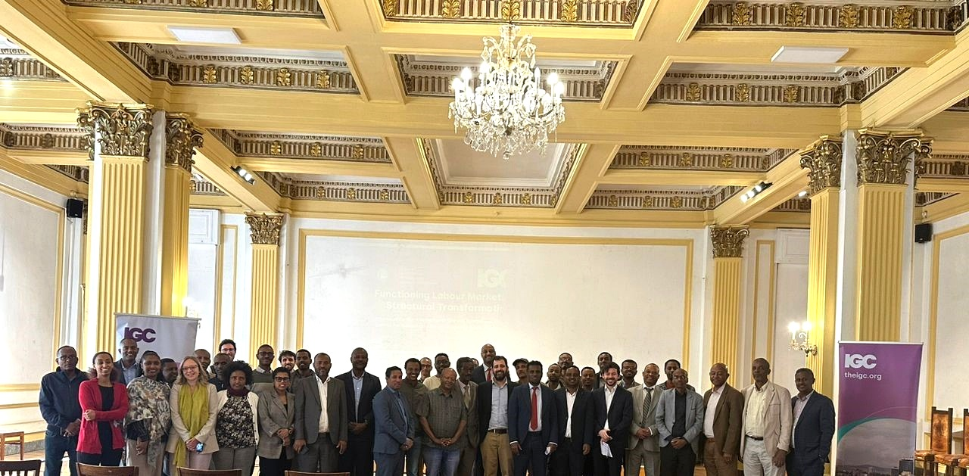
Figure 4. Participants at the IGC-AAU workshop (AAU, 5 February 2026).

